**DЕLHI TЕCHNOLOGICAL UNIVЕRSITY**



**DIGITAL ELECTRONICS**

**PRACTICAL FILЕ**

SUBMITЕD BY:

PREET PAL SINGH

2K19/CO/293

SUBMITЕD TO:

Dr. Jayanthi Anbukumar

**INDEX**

|  |  |  |
| --- | --- | --- |
| **S.N** | **NAME OF EXPERIMENTS** | **DATE OF EXPERIMENTS** |
| 1. | To verify and interpret the logic and truth table for AND, OR, NOT, NAND, NOR, Ex-OR, Ex-NOR gates using RTL (Resistor Transistor Logic), DTL (Diode Transistor Logic) and TTL (Transistor Transistor Logic) logics in simulator 1 and verify the truth table for AND, OR, NOT, NAND, NOR, Ex-OR, Ex-NOR gates in simulator 2. | 21/JAN/2021 |
| 2. | To verify the truth table of half adder and full adder by using XOR and NAND gates respectively and analyse the working of half adder and full adder circuit with the help of LEDs in simulator 1 and verify the truth table only of half adder and full adder in simulator 2. | 04/FEB/2021 |
| 3. | To verify the truth table of half subtractor by using the ICs of XOR, NOT and AND gates and of full subtractor by using the ICs of XOR, AND, NOT and OR gates respectively and analyse the working of half subtractor and full subtractor circuit with the help of LEDs in simulator 1 and verify the truth table only of half subtractor and full subtractor in simulator 2. | 11/FEB/2021 |
| 4. | To implement the logic functions i.e. AND, OR, NOT, Ex-OR, Ex- NOR and a logical expression with the help of NAND and NOR universal gates respectively. | 25/FEB/2021 |
| 5. | To verify the truth table and timing diagram of NOR gate latch using NOR gate IC and analyse the circuit of NOR gate latch with the help of LEDs display. | 25/FEB/2021 |
| 6. | To verify the truth table and timing diagram of RS, JK, T and D flip-flops by using NAND & NOR gates ICs and analyse the circuit of RS, JK, T and D flip-flops with the help of LEDs display. | 04/MAR/2021 |

**EXPERIMENT 1**

**AIM:**

To verify and interpret the logic and truth table for AND, OR, NOT, NAND, NOR, Ex-OR, Ex-NOR gates using RTL (Resistor Transistor Logic), DTL (Diode Transistor Logic) and TTL (Transistor Transistor Logic) logics in simulator 1 and verify the truth table for AND, OR, NOT, NAND, NOR, Ex-OR, Ex-NOR gates in simulator 2.

### 1) AND gate

### Theory:

The AND gate is an electronic circuit that gives a high output (1) only if all its inputs are high. A dot (.) is used to show the AND operation i.e. A.B or can be written as AB

**Y= A.B**  
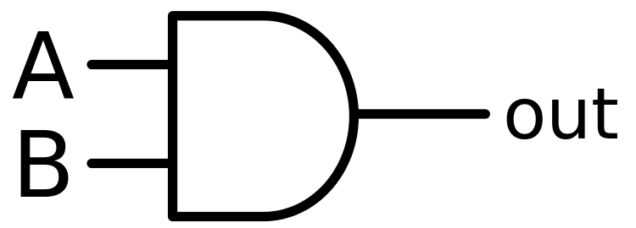  
**Figure-1:Logic Symbol of AND Gate**  
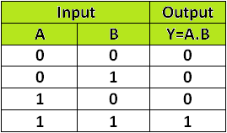  
**Figure-2:Truth Table of AND Gate**

A simple 2-input logic AND gate can be constructed using RTL (Resistor-Transistor-Logic) switches connected together as shown below with the inputs connected directly to the transistor bases. Both transistors must be saturated “ON” for an output at Q.

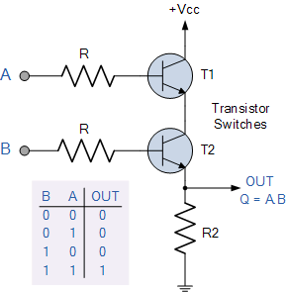  
**Figure-3: AND Gate through RTL logic**

### Procedure:

**Simulator 1:**

Step-1) Connect the supply(+5V)    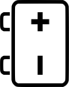   to the circuit.  
Step-2) Press the switches for inputs "A" and "B".  
The switch in ON state is      and the switch in OFF state is      
  
Step-3) The bulb does not glow if any one or both the switches (2 and 3) are OFF and glows only if both the switches (2 and 3) are ON.  
  
The bulb in OFF state is  and the bulb in ON state is  .  
Step-4) Repeat step-2 and step-3 for all state of inputs.

#### Simulator 2:

Step-1) Enter the Boolean input "A" and "B".  
Step-2) Enter the Boolean output for your corresponding inputs.  
Step-3) Click on "Check" Button to verify your output.  
Step-4) Click "Print" if you want to get print out of Truth Table.

### [Simulation](https://de-iitr.vlabs.ac.in/exp/truth-table-gates/simulation.html)

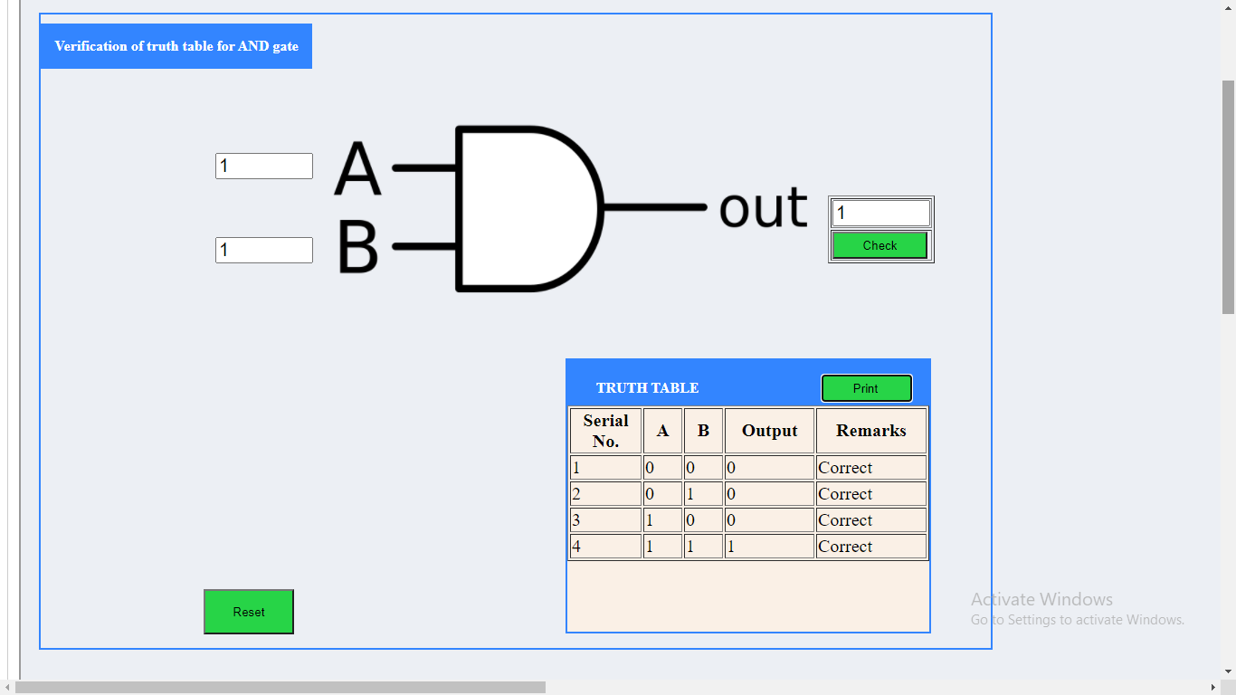

### 2) OR gate

### Theory:

The OR gate is an electronic circuit that gives a high output (1) if one or more of its inputs are high. A plus (+) is used to show the OR operation.

**Y= A+B**

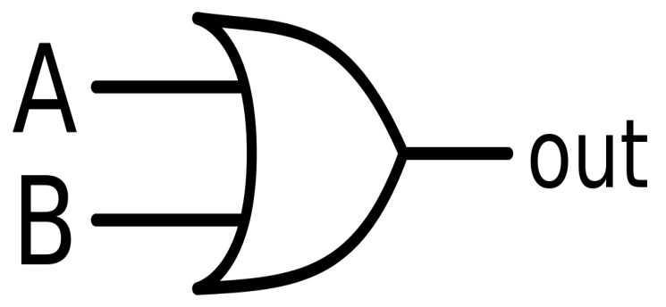  
**Figure-4:Logic Symbol of OR Gate**  
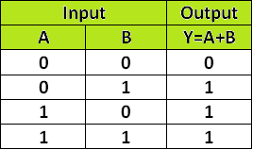  
**Figure-5:Truth Table of OR Gate**

OR gate can be realized by DRL (Diode-Resistance-Logic) or by TTL (Transistor-Transistor-Logic). Presently, we will learn how to implement the OR gate using DRL (Diode-Resistance-Logic). To realise OR gate, we will use a diode at every input of the OR gate. The anode part of diode is connected with input while the cathode part is joined together and a resistor, connected with the cathode is grounded. In this case, we have taken two inputs which can be seen in the circuit below.

When both the inputs are at logic 0 or low state then the diodes D1 and D2 become reverse biased. Since the anode terminal of diode is at lower voltage level than the cathode terminal, so diode will act as open circuit so there is no voltage across resistor and hence output voltage is same as ground. When either of the diodes is at logic 1 or high state then the diode corresponding to that input is forward bias. Since this time anode is at high voltage than cathode therefore current will flow through forward biased diode and this current then appears on resistor causing high voltage at output terminal also. Hence at output we get high or logic 1 or +5V. So, if any or both inputs are high, the output will be high or “1”.

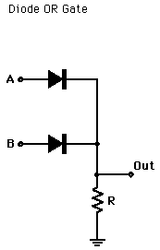  
**Figure-6: OR Gate through DRL logic**

### Procedure:

**Simulator 1:**

Step-1) Connect the supply (+5V)       to the circuit.  
Step-2) Press the switches for inputs "A" and "B".  
The switch in ON state is      and the switch in OFF state is      
Step-3) The bulb glows if any one or both the switches are ON else it won't glow.  
The bulb in OFF state is  and the bulb in ON state is  .  
Step-4) Repeat step-2 and step-3 for all state of inputs.

#### Simulator 2:

Step-1) Enter the Boolean input "A" and "B".  
Step-2) Enter the Boolean output for your corresponding inputs.  
Step-3) Click on "Check" Button to verify your output.  
Step-4) Click "Print" if you want to get print out of Truth Table.

### [Simulation](https://de-iitr.vlabs.ac.in/exp/truth-table-gates/simulation.html)

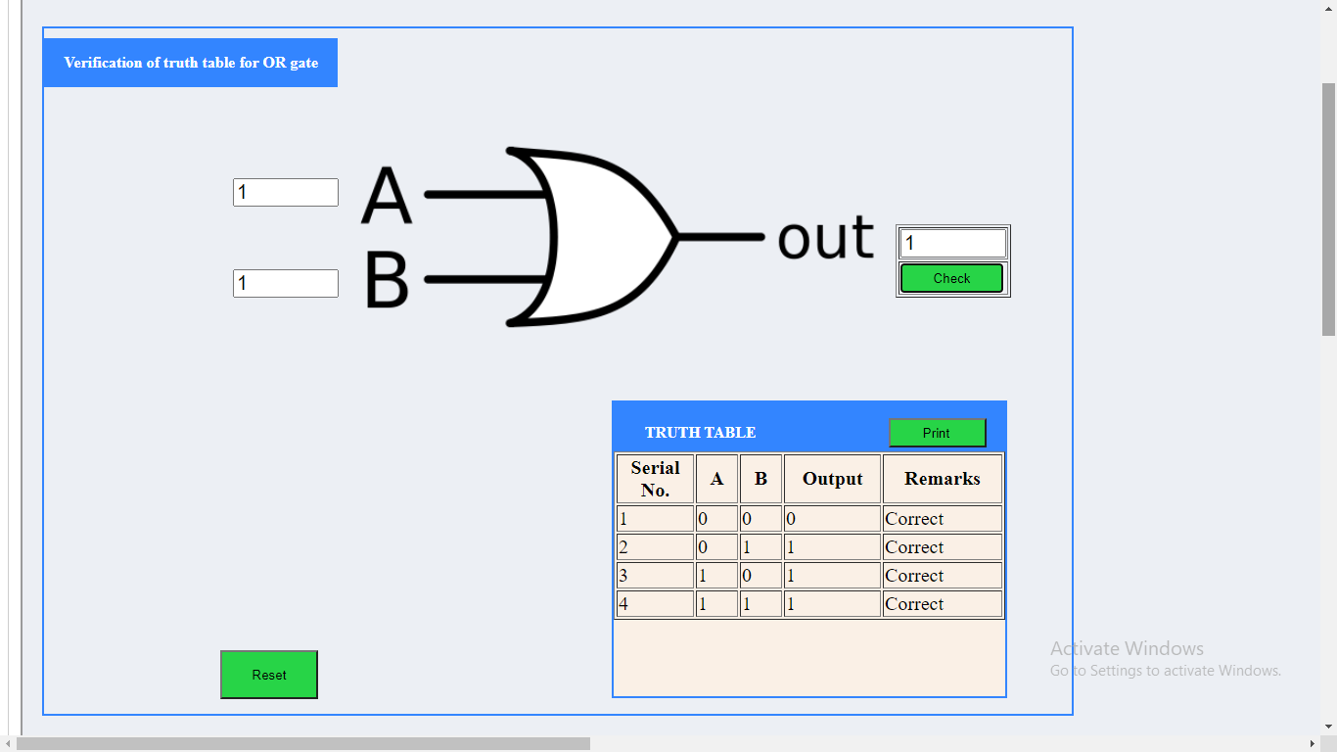

### 3) NOT gate

### Theory:

The NOT gate is an electronic circuit that produces an inverted version of the input at its output. It is also known as an inverter. If the input variable is A, the inverted output is known as NOT A. This is also shown as A' or A with a bar over the top, as shown at the outputs.

**Y= A'**

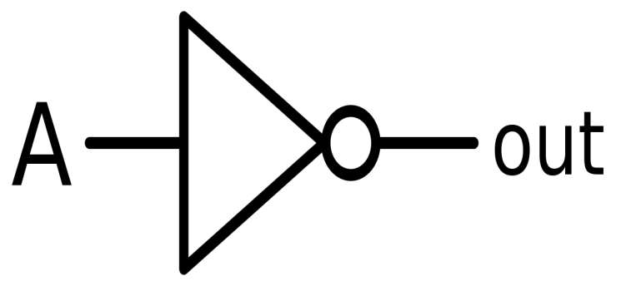  
**Figure-7:Logic Symbol of NOT Gate**  
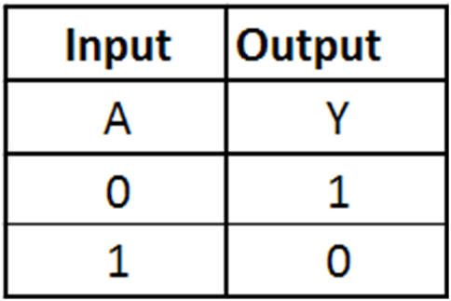  
**Figure-8:Truth Table of NOT Gate**

NOT gate can be realized through transistor. The input is connected through resistor R2 to the transistor’s base. When no voltage is present on the input, the transistor turns off. When the transistor is off, no current flows through the collector-emitter path. Thus, current from the supply voltage (Vcc) flows through resistor R1 to the output. In this way, the circuit’s output is high when its input is low.

When voltage is present at the input, the transistor turns on, allowing current to flow through the collector-emitter circuit directly to ground. This ground path creates a shortcut that bypasses the output, which causes the output to go low.

In this way, the output is high when the input is low and low when the input is high.

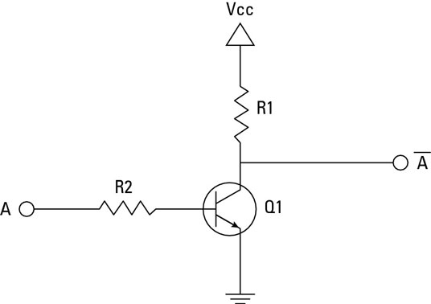  
**Figure-9: NOT Gate through Transistor**

### Procedure:

**Simulator 1:**

### Step-1) Connect the supply (+5V)    https://de-iitr.vlabs.ac.in/exp/truth-table-gates/images/batt.png   to the circuit. Step-2) Press the switch 1 to connect battery to the circuit. Step-3) Press the switch 2 for input "A" . The switch in ON state is  https://de-iitr.vlabs.ac.in/exp/truth-table-gates/images/switchoff.png    and the switch in OFF state is https://de-iitr.vlabs.ac.in/exp/truth-table-gates/images/switchon.png    Step-4) The bulb glows if switch 2 is OFF else it won't glow. The bulb in OFF state is https://de-iitr.vlabs.ac.in/exp/truth-table-gates/images/bulboff1.png and the bulb in ON state is https://de-iitr.vlabs.ac.in/exp/truth-table-gates/images/bulbon1.png .

### Simulator 2:

Step-1) Enter the Boolean input "A".  
Step-2) Enter the Boolean output for your corresponding input.  
Step-3) Click on "Check" Button to verify your output.  
Step-4) Click "Print" if you want to get print out of Truth Table.

### [Simulation](https://de-iitr.vlabs.ac.in/exp/truth-table-gates/simulation.html)

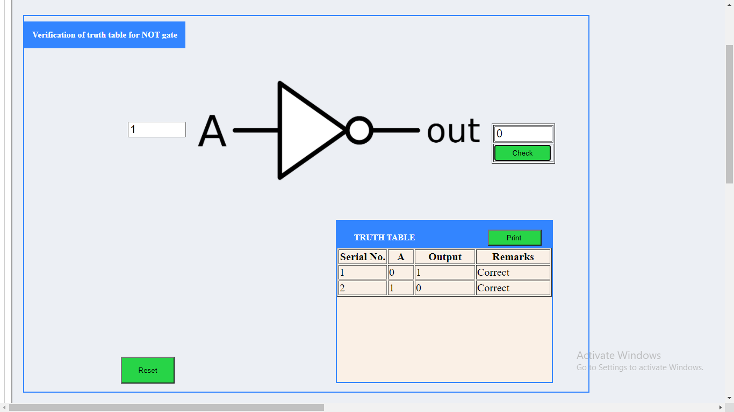

### 4) NAND gate

### Theory:

This is a NOT-AND gate which is equal to an AND gate followed by a NOT gate. The outputs of all NAND gates are high if any of the inputs are low. The symbol is an AND gate with a small circle on the output. The small circle represents inversion.

**Y= AB**

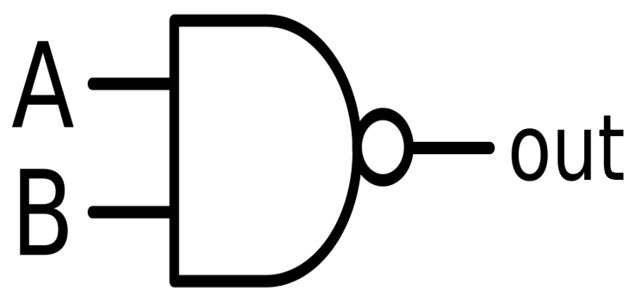  
**Figure-10:Logic Symbol of NAND Gate**  
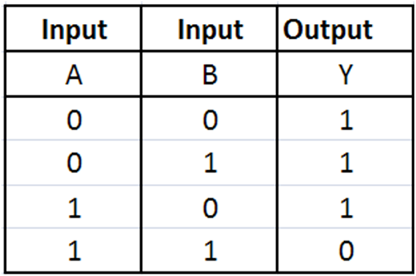  
**Figure-11:Truth Table of NAND Gate**

A simple 2-input logic NAND gate can be constructed using RTL (Resistor-transistor-logic) switches connected together as shown below with the inputs connected directly to the transistor bases. Either transistor must be cut-off or “OFF” for an output at Q.

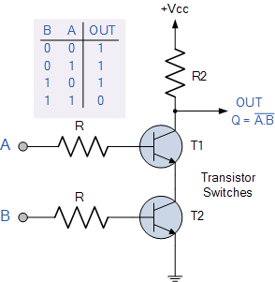  
**Figure-12: NAND gate through RTL Logic.**

### Procedure:

**Simulator 1:**

### Step-1) Connect the supply (+5V)    https://de-iitr.vlabs.ac.in/exp/truth-table-gates/images/batt.png   to the circuit. Step-2) Press the switch 1 to connect battery to the circuit. Step-3) Press the switches 2 and 3 for inputs "A" and "B". The switch in ON state is  https://de-iitr.vlabs.ac.in/exp/truth-table-gates/images/switchoff.png    and the switch in OFF state is https://de-iitr.vlabs.ac.in/exp/truth-table-gates/images/switchon.png    Step-4) The bulb glows if any one or both the switches are OFF else it won't glow. The bulb in OFF state is https://de-iitr.vlabs.ac.in/exp/truth-table-gates/images/bulboff1.png and the bulb in ON state is https://de-iitr.vlabs.ac.in/exp/truth-table-gates/images/bulbon1.png .

#### Simulator 2:

Step-1) Enter the Boolean input "A" and "B".  
Step-2) Enter the Boolean output for your corresponding inputs.  
Step-3) Click on "Check" Button to verify your output.  
Step-4) Click "Print" if you want to get print out of Truth Table.

### [Simulation](https://de-iitr.vlabs.ac.in/exp/truth-table-gates/simulation.html)

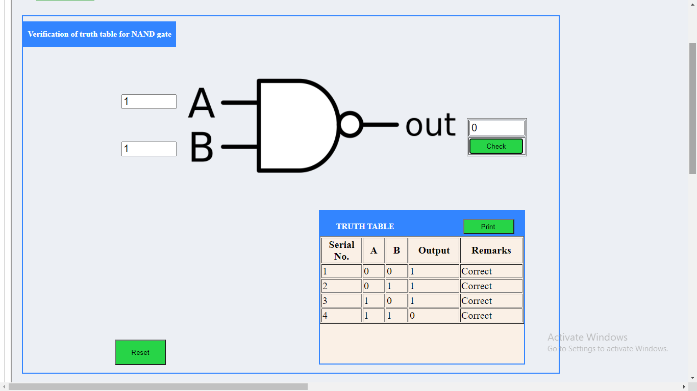

### 5) NOR gate

### Theory:

This is a NOT-OR gate which is equal to an OR gate followed by a NOT gate. The outputs of all NOR gates are low if any of the inputs are high. The symbol is an OR gate with a small circle on the output. The small circle represents inversion.

**Y= A+B**

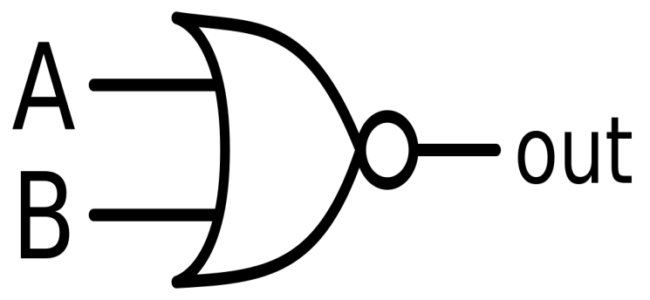  
**Figure-13: Logic Symbol of NOR gate**  
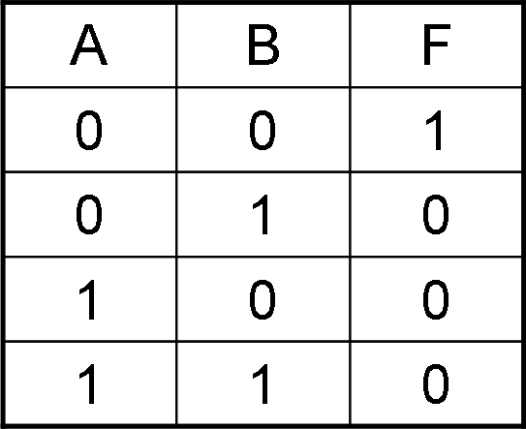  
**Figure-14: Truth Table of NOR gate**

A simple 2-input logic NOR gate can be constructed using RTL (Resistor-transistor-logic) switches connected together as shown below with the inputs connected directly to the transistor bases. Both transistors must be cut-off or “OFF” for an output at Q.

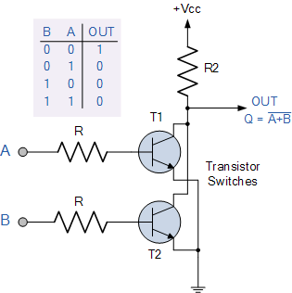  
**Figure-15: NOR gate through RTL Logic.**

### Procedure:

**Simulator 1:**

### Step-1) Connect the supply (+5V)    https://de-iitr.vlabs.ac.in/exp/truth-table-gates/images/batt.png   to the circuit. Step-2) Press the switch 1 to connect battery to the circuit. Step-3) Press the switches 2 and 3 for inputs "A" and "B". The switch in ON state is  https://de-iitr.vlabs.ac.in/exp/truth-table-gates/images/switchoff.png    and the switch in OFF state is https://de-iitr.vlabs.ac.in/exp/truth-table-gates/images/switchon.png    Step-4)The bulb glows if both the switches are OFF else it won't glow. The bulb in OFF state is https://de-iitr.vlabs.ac.in/exp/truth-table-gates/images/bulboff1.png and the bulb in ON state is https://de-iitr.vlabs.ac.in/exp/truth-table-gates/images/bulbon1.png .

#### Simulator 2:

Step-1) Enter the Boolean input "A" and "B".  
Step-2) Enter the Boolean output for your corresponding inputs.  
Step-3) Click on "Check" Button to verify your output.  
Step-4) Click "Print" if you want to get print out of Truth Table.

### [Simulation](https://de-iitr.vlabs.ac.in/exp/truth-table-gates/simulation.html)

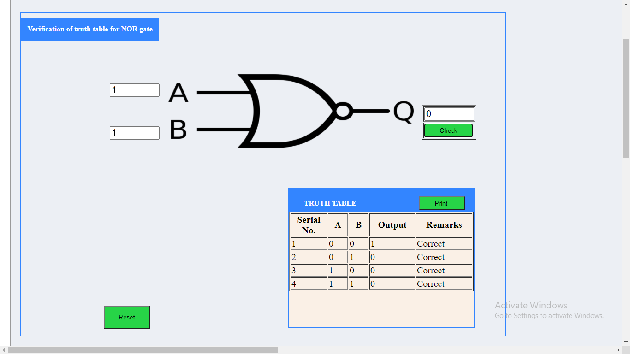

### 6) Ex-OR gate

### Theory:

The 'Exclusive-OR' gate is a circuit which will give a high output if either, but not both of its two inputs are high. An encircled plus sign (⊕) is used to show the Ex-OR operation.

**Y= A⊕B**

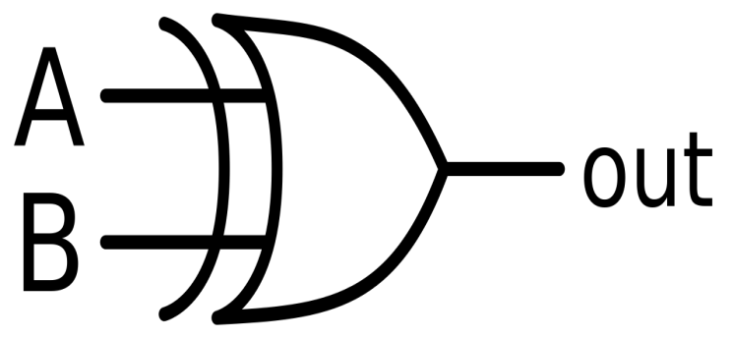  
**Figure-16: Logic Symbol of Ex-OR gate**  
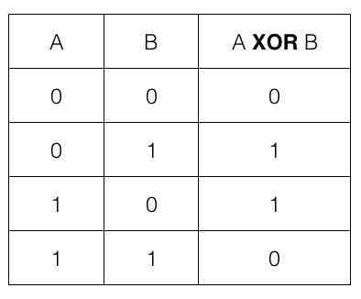  
**Figure-17: Truth Table of Ex-OR gate**

Ex-OR gate is created from AND, NAND and OR gates. The output is high only when both the inputs are different.

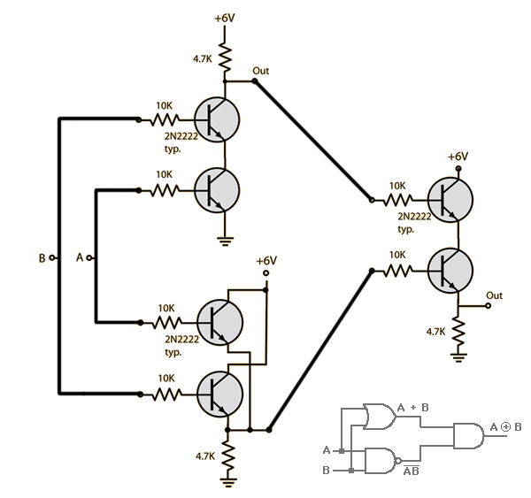  
**Figure-18: Ex-OR gate through RTL Logic.**

### Procedure:

**Simulator 1:**

### Step-1) Connect the supply(+5V)    https://de-iitr.vlabs.ac.in/exp/truth-table-gates/images/SP2.png   to the circuit   . Step-2) Press the switches for inputs "A" and "B". The switch in ON state is  https://de-iitr.vlabs.ac.in/exp/truth-table-gates/images/switchoff.png    and the switch in OFF state is https://de-iitr.vlabs.ac.in/exp/truth-table-gates/images/switchon.png    Step-3) The bulb glows if one of the switches is ON and one of the switches is OFF else it won't glow. The bulb in OFF state is https://de-iitr.vlabs.ac.in/exp/truth-table-gates/images/bulboff1.png and the bulb in ON state is https://de-iitr.vlabs.ac.in/exp/truth-table-gates/images/bulbon1.png .

#### Simulator 2:

Step-1) Enter the Boolean input "A" and "B".  
Step-2) Enter the Boolean output for your corresponding inputs.  
Step-3) Click on "Check" Button to verify your output.  
Step-4) Click "Print" if you want to get print out of Truth Table.

### [Simulation](https://de-iitr.vlabs.ac.in/exp/truth-table-gates/simulation.html)

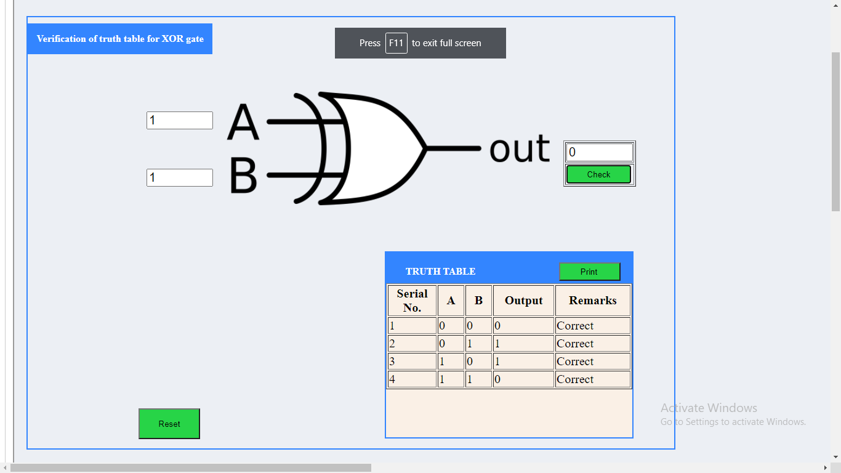

### 7) Ex-NOR gate

### Theory:

The 'Exclusive-NOR' gate circuit does the opposite to the EX-OR gate. It will give a low output if either, but not both of its two inputs are high. The symbol is an EX-OR gate with a small circle on the output. The small circle represents inversion.

**Y= A⊕B**

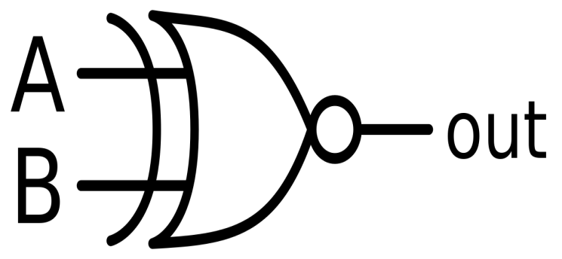  
**Figure-19:Logic Symbol of Ex-NOR gate**  
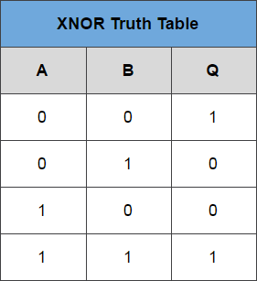  
**Figure-20:Truth Table of Ex-NOR gate**

Ex-NOR gate is created from AND, NOT and OR gates. The output is high only when both the inputs are same.

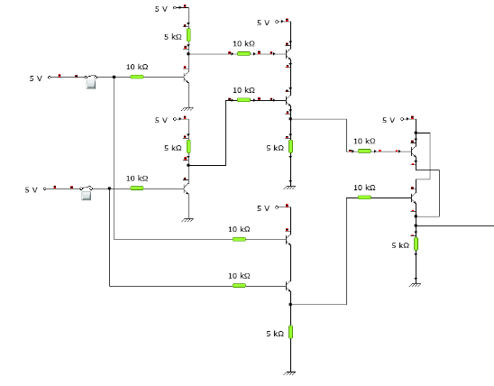

**Figure-21: Ex-NOR gate through RTL Logic.**

### Procedure:

**Simulator 1:**

Step-1) Connect the supply (+5V)       to the circuit   .  
Step-2) Press the switches for inputs "A" and "B".  
The switch in ON state is      and the switch in OFF state is      
Step-3) The bulb glows if both the switches are ON or if both the switches are OFF else it won't glow.  
The bulb in OFF state is  and the bulb in ON state is  .

#### Simulator 2:

Step-1) Enter the Boolean input "A" and "B".  
Step-2) Enter the Boolean output for your corresponding inputs.  
Step-3) Click on "Check" Button to verify your output.  
Step-4) Click "Print" if you want to get print out of Truth Table.

### [Simulation](https://de-iitr.vlabs.ac.in/exp/truth-table-gates/simulation.html)

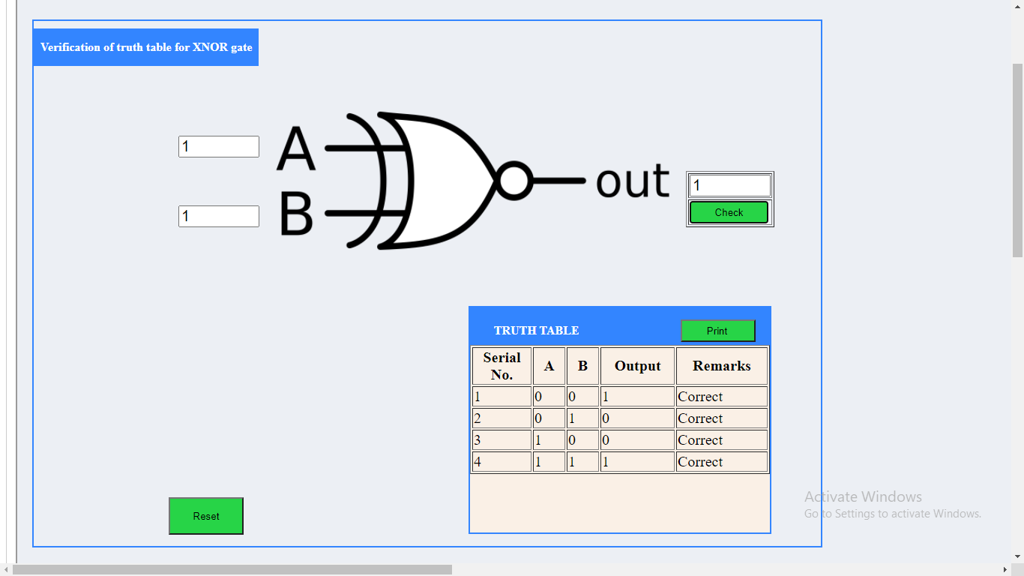

**EXPERIMENT 2**

**AIM:**

#### To verify the truth table of half adder and full adder by using XOR and NAND gates respectively and analyse the working of half adder and full adder circuit with the help of LEDs in simulator 1 and verify the truth table only of half adder and full adder in simulator 2.

### THEORY:

Adders are digital circuits that carry out addition of numbers. Adders are a key component of arithmetic logic unit. Adders can be constructed for most of the numerical representations like Binary Coded Decimal (BCD), Excess – 3, Gray code, Binary etc. out of these, binary addition is the most frequently performed task by most common adders. Apart from addition, adders are also used in certain digital applications like table index calculation, address decoding etc.  
  
Binary addition is similar to that of decimal addition. Some basic binary additions are shown below.

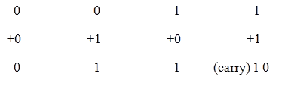  
**Figure 1. Schematic representation of half adder**

### Half Adder

Half adder is a combinational circuit that performs simple addition of two binary numbers. If we assume A and B as the two bits whose addition is to be performed,the block diagram and a truth table for half adder with A, B as inputs and Sum, Carry as outputs can be tabulated as follows.

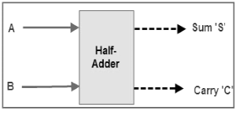  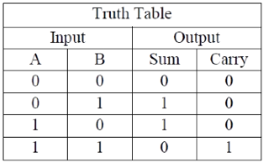

**Figure 2. Block diagram and truth table of half adder**

The sum output of the binary addition carried out above is similar to that of an Ex-OR operation while the carry output is similar to that of an AND operation. The same can be verified with help of Karnaugh Map.  
The truth table and K Map simplification and logic diagram for sum output is shown below.

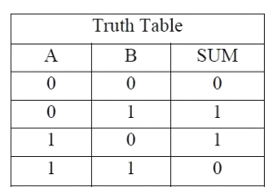  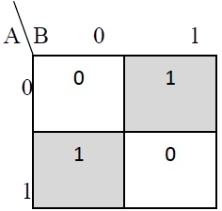  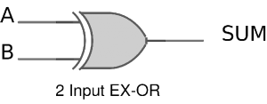

**Figure 3. Truth table, K Map simplification and Logic diagram for sum output of half adder**

**Sum = A B' + A' B**

The truth table and K Map simplification and logic diagram for carry is shown below.

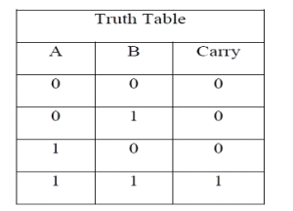  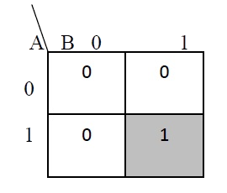  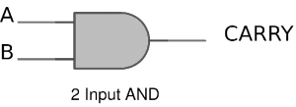

**Figure 4. Truth table, K Map simplification and Logic diagram for sum output of half adder**

**Carry = AB**

If A and B are binary inputs to the half adder, then the logic function to calculate sum S is Ex – OR of A and B and logic function to calculate carry C is AND of A and B. Combining these two, the logical circuit to implement the combinational circuit of half adder is shown below.

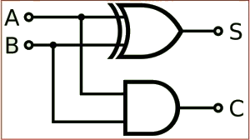  
  
  
**Figure 5. Half Adder Logic Diagram**

As we know that NAND and NOR are called universal gates as any logic system can be implemented using these two, the half adder circuit can also be implemented using them. We know that a half adder circuit has one Ex – OR gate and one AND gate.

### Half Adder using NAND gates

Five NAND gates are required in order to design a half adder. The circuit to realize half adder using NAND gates is shown below.

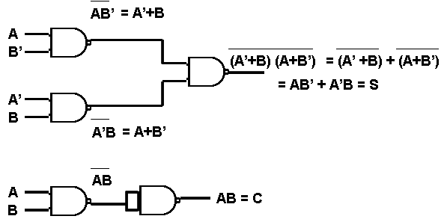  
**Figure 6. Realization of half adder using NAND gates**

### Half Adder using NOR gates

Five NOR gates are required in order to design a half adder. The circuit to realize half adder using NOR gates is shown below.

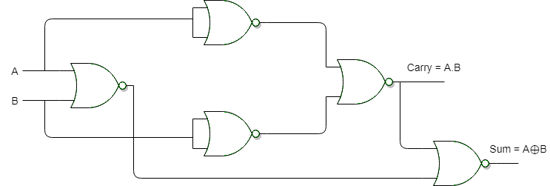  
**Figure 7. Realization of half adder using NOR Gates**

### Full Adder

Full adder is a digital circuit used to calculate the sum of three binary bits. Full adders are complex and difficult to implement when compared to half adders. Two of the three bits are same as before which are A, the augend bit and B, the addend bit. The additional third bit is carry bit from the previous stage and is called 'Carry' – in generally represented by CIN. It calculates the sum of three bits along with the carry. The output carry is called Carry – out and is represented by Carry OUT.

The block diagram of a full adder with A, B and CIN as inputs and S, Carry OUT as outputs is shown below.

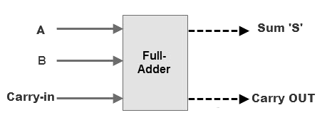   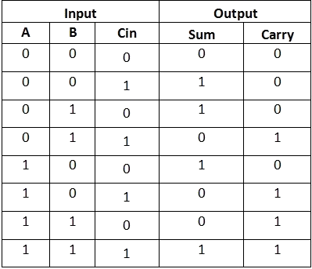  
**Figure 8. Full Adder Block Diagram and Truth Table**

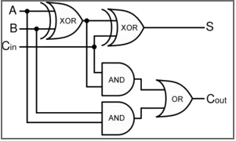

**Figure 9. Full Adder Logic Diagram**

Based on the truth table, the Boolean functions for Sum (S) and Carry – out (COUT) can be derived using K – Map.

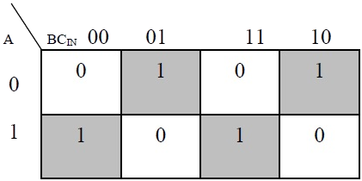

**Figure 10. The K-Map simplified equation for sum is S = A'B'Cin + A'BCin' + ABCin**

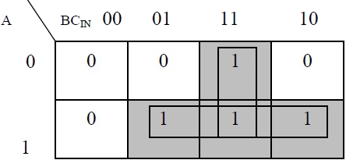

**Figure 11. The K-Map simplified equation for COUT is COUT = AB + ACIN + BCIN**

In order to implement a combinational circuit for full adder, it is clear from the equations derived above, that we need four 3-input AND gates and one 4-input OR gates for Sum and three 2-input AND gates and one 3-input OR gate for Carry – out.

### 2.1) Full Adder using NAND gates

As mentioned earlier, a NAND gate is one of the universal gates and can be used to implement any logic design. The circuit of full adder using only NAND gates is shown below.

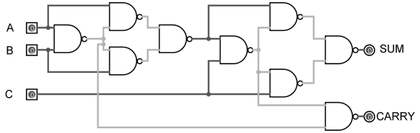

**Figure 12. Full Adder using NAND gates**

### 2.2) Full Adder using NOR gates

As mentioned earlier, a NOR gate is one of the universal gates and can be used to implement any logic design. The circuit of full adder using only NOR gates is shown below.

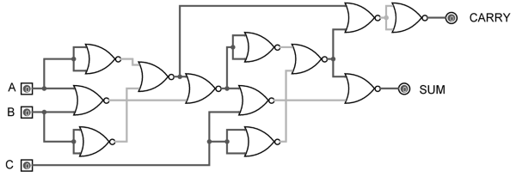  
**Figure 13. Full Adder using NOR gates**

### PROCEDURE:

### HALF ADDER

#### Simulator 1:

Step-1) Connect the supply(+5V)       to the circuit.  
Step-2) First press "ADD" button to add basic state of your output in the given table.  
Step-3) Press the switches to select the required inputs "A" and "B".  
Step-4) Press "ADD" button to add your inputs and outputs in the given table.  
Step-5) Repeat steps 3 & 4 for next state of inputs and their corresponding outputs.  
Step-6) Press the "PRINT" button after completing your simulation to get your results.  
Step-7) Press the "RESET" button whenever you want to refresh your simulator.

### [Simulation](https://de-iitr.vlabs.ac.in/exp/truth-table-gates/simulation.html)



#### Simulator 2:

Step-1) Enter the Boolean input "A" and "B".  
Step-2) Enter the Boolean output for your corresponding inputs.  
Step-3) Click on "Circuit" button to check the circuit diagram for half adder.  
Step-4) Click on "Check" Button to verify your output.  
Step-5) Click "Print" if you want to get print out of Truth Table.  
Step-6) Click on "Reset" button if you want to reset input and outputs.

### [Simulation](https://de-iitr.vlabs.ac.in/exp/truth-table-gates/simulation.html)



### FULL ADDER

#### Simulator 1:

Step-1) Connect the supply(+5V)       to the circuit.  
Step-2) First press "ADD" button to add basic state of your output in the given table.  
Step-3) Press the switches to select the required inputs "A" and "B" and "Cin".  
Step-4) Press "ADD" button to add your inputs and outputs in the given table.  
Step-5) Repeat steps 3 & 4 for next state of inputs and their corresponding outputs.  
Step-6) Press the "PRINT" button after completing your simulation to get your results.  
Step-7) Press the "RESET" button whenever you want to refresh your simulator.

### [Simulation](https://de-iitr.vlabs.ac.in/exp/truth-table-gates/simulation.html)



#### Simulator 2:

Step-1) Enter the Boolean input "A" and "B" and "Cin".  
Step-2) Enter the Boolean output for your corresponding inputs.  
Step-3) Click on "Circuit" button to check the circuit diagram for full adder.  
Step-4) Click on "Check" Button to verify your output.  
Step-5) Click "Print" if you want to get print out of Truth Table.  
Step-6) Click on "Reset" button if you want to reset input and outputs.

### [Simulation](https://de-iitr.vlabs.ac.in/exp/truth-table-gates/simulation.html)



**EXPERIMENT 3**

**AIM:**

#### To verify the truth table of half subtractor by using the ICs of XOR, NOT and AND gates and of full subtractor by using the ICs of XOR, AND, NOT and OR gates respectively and analyse the working of half subtractor and full subtractor circuit with the help of LEDs in simulator 1 and verify the truth table only of half subtractor and full subtractor in simulator 2.

### THEORY:

Subtractor circuits take two binary numbers as input and subtract one binary number input from the other binary number input. Similar to adders, it gives out two outputs, difference and borrow (carry-in the case of Adder). There are two types of subtractors.

1) Half Subtractor  
2) Full Subtractor

### 1) Half Subtractor

The half-subtractor is a combinational circuit which is used to perform subtraction of two bits. It has two inputs, A (minuend) and B (subtrahend) and two outputs Difference and Borrow. The logic symbol and truth table are shown below.

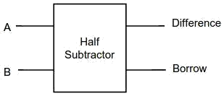  
**Figure-1:Logic Symbol of Half subtractor**

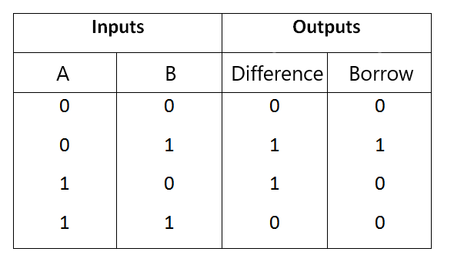  
**Figure-2:Truth Table of Half subtractor**

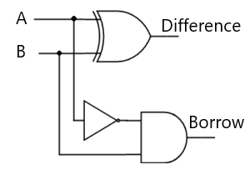

**Figure-3:Circuit Diagram of Half subtractor**

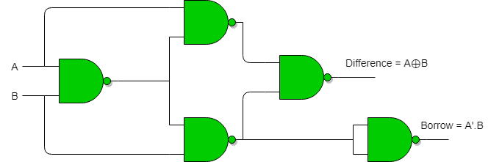

**Figure-3.1: Half Subtractor using NAND gates**

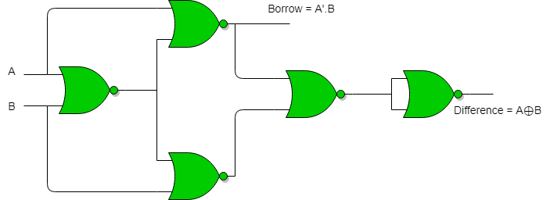

**Figure-3.2: Half Subtractor using NOR gates**

From the above truth table we can find the boolean expression.

**Difference = A ⊕ B  
Borrow = A' B**

From the equation we can draw the half-subtractor circuit as shown in the figure 3.

### 2) Full Subtractor

A full subtractor is a combinational circuit that performs subtraction involving three bits, namely A (minuend), B (subtrahend), and Bin (borrow-in) . It accepts three inputs: A (minuend), B (subtrahend) and a Bin (borrow bit) and it produces two outputs: D (difference) and Bout (borrow out). The logic symbol and truth table are shown below.

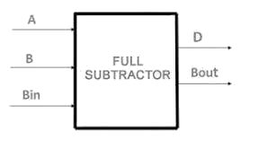  
**Figure-4:Logic Symbol of Full subtractor**  
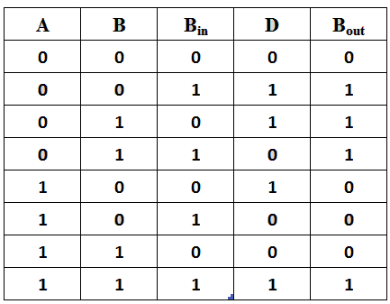  
**Figure-5:Truth Table of Full subtractor**

From the above truth table we can find the boolean expression.

**D = A ⊕ B ⊕ Bin  
Bout = A' Bin + A' B + B Bin**

From the equation we can draw the Full-subtractor circuit as shown in the figure 6.

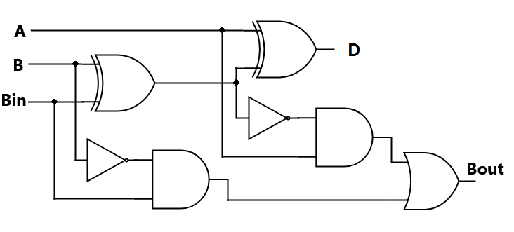  
**Figure-6: Circuit Diagram of Full subtractor**

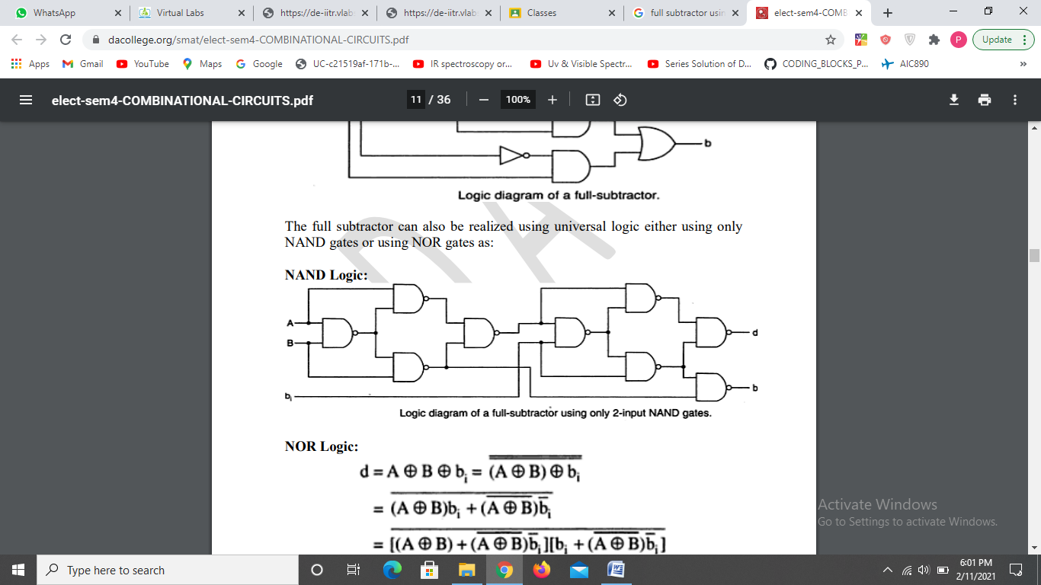

**Figure-6.1: Full Subtractor using NAND gates**

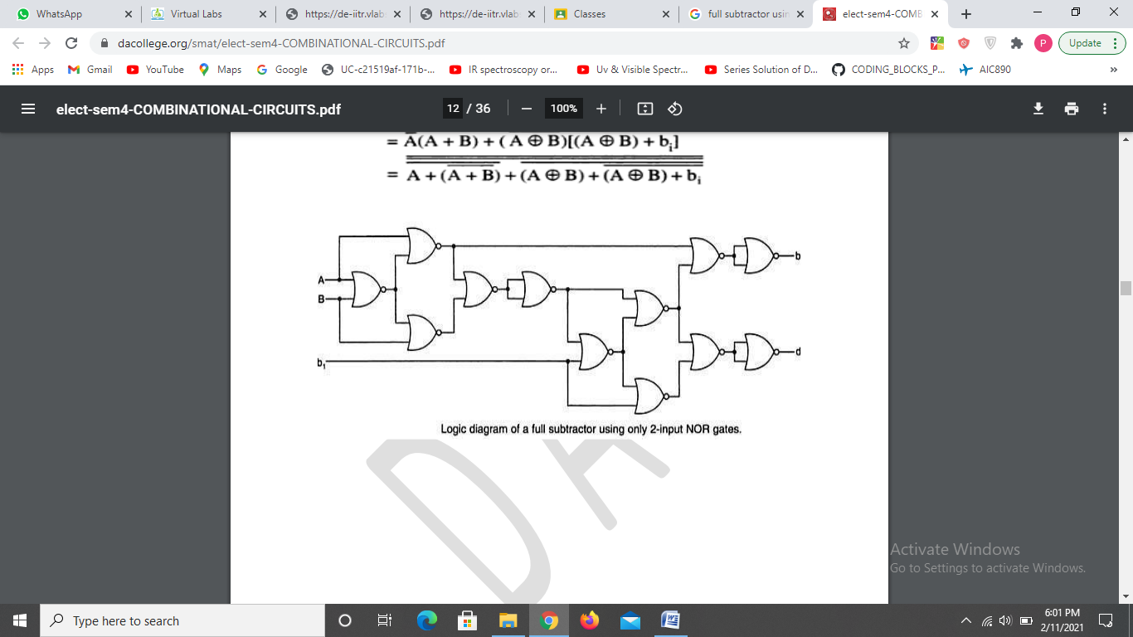

**Figure-6.2: Full Subtractor using NOR gates**

### PROCEDURE:

### HALF SUBTRACTOR

#### Simulator 1:

Step-1) Connect the Supply(+5V)       to the circuit.  
Step-2) First press "ADD" button to add basic state of your output in the given table.  
Step-3) Press the switches to select the required inputs "A" and "B".  
Step-4) Press "ADD" button to add your inputs and outputs in the given table.  
Step-5) Repeat steps 3&4 for next state of inputs and their corresponding outputs.  
Step-6) Press the "PRINT" button after completing your simulation to get your results.

### [Simulation](https://de-iitr.vlabs.ac.in/exp/truth-table-gates/simulation.html)



#### Simulator 2:

Step-1) Enter the Boolean input "A" and "B".  
Step-2) Enter the Boolean output for your corresponding inputs.  
Step-3) Click on "Check" Button to verify your output.  
Step-4) Click "Print" if you want to get print out of Truth Table.  
Step-5) Click "Reset" if you want to reset inputs and outputs.

### [Simulation](https://de-iitr.vlabs.ac.in/exp/truth-table-gates/simulation.html)



### FULL SUBTRACTOR

#### Simulator 1:

Step-1) Connect the Supply(+5V)       to the circuit.  
Step-2) First press "ADD" button to add basic state of your output in the given table.  
Step-3) Press the switches to select the required inputs "A" and "B" and "Bin".  
Step-4) Press "ADD" button to add your inputs and outputs in the given table.  
Step-5) Repeat steps 3&4 for next state of inputs and their corresponding outputs.  
Step-6) Press the "PRINT" button after completing your simulation to get your results.

### [Simulation](https://de-iitr.vlabs.ac.in/exp/truth-table-gates/simulation.html)



#### Simulator 2:

Step-1) Enter the Boolean inputs "A" and "B" and "Bin".  
Step-2) Enter the Boolean output for your corresponding inputs.  
Step-3) Click on "Check" Button to verify your output.  
Step-4) Click "Print" if you want to get print out of Truth Table.  
Step-5) Click "Reset" if you want to reset inputs and outputs.

### [Simulation](https://de-iitr.vlabs.ac.in/exp/truth-table-gates/simulation.html)



**EXPERIMENT-4**

**AIM:**

To implement the logic functions i.e. AND, OR, NOT, Ex-OR, Ex- NOR and a logical expression with the help of NAND and NOR universal gates respectively.

### THEORY:

Logic gates are electronic circuits which perform logical functions on one or more inputs to produce one output. There are seven logic gates. When all the input combinations of a logic gate are written in a series and their corresponding outputs written along them, then this input/ output combination is called Truth Table.

### Nand gate as Universal gate

NAND gate is actually a combination of two logic gates i.e. AND gate followed by NOT gate. So its output is complement of the output of an AND gate.This gate can have minimum two inputs. By using only NAND gates, we can realize all logic functions: AND, OR, NOT, Ex-OR, Ex-NOR, NOR. So this gate is also called as universal gate.

#### NAND gates as OR gate

From DeMorgan’s theorems:  
(A.B)’ = A’ + B’  
(A’.B’)’ = A’’ + B’’ = A + B  
So, give the inverted inputs to a NAND gate, obtain OR operation at output.

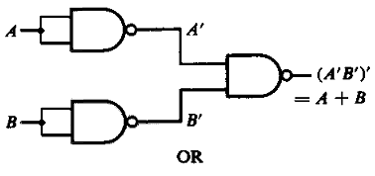  
**Figure-1:NAND gates as OR gate**

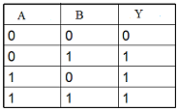  
**Figure-2:Truth table of OR**

#### NAND gates as AND gate

A NAND produces complement of AND gate. So, if the output of a NAND gate is inverted, overall output will be that of an AND gate.

**Y = ((A.B)’)’**  
**Y = (A.B)**

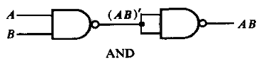  
**Figure-3:NAND gates as AND gate**

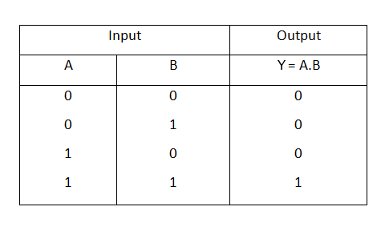  
**Figure-4:Truth table of AND**

#### NAND gates as Ex-OR gate

The output of a two input Ex-OR gate is shown by: Y = A’B + AB’. This can be achieved with the logic diagram shown in the left side.

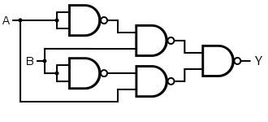  
**Figure-5: NAND gate as Ex-OR gate**

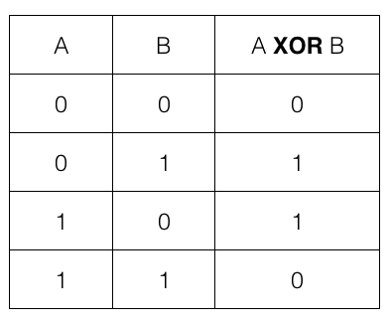  
**Figure-6: Truth table of Ex-OR**

#### NAND gates as Ex-NOR gate

Ex-NOR gate is actually Ex-OR gate followed by NOT gate. So give the output of Ex-OR gate to a NOT gate, overall output is that of an Ex-NOR gate.

**Y = AB+ A’B’**

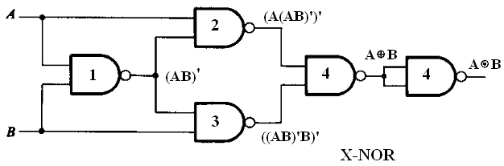  
**Figure-7: NAND gates as Ex-NOR gate**

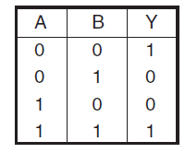  
**Figure-8: Truth table of Ex-NOR**

#### Implementing the simplified function with NAND gates only

We can now start constructing the circuit. First note that the entire expression is inverted and we have three terms ANDed. This means that we must use a 3-input NAND gate. Each of the three terms is, itself, a NAND expression. Finally, negated single terms can be generates with a 2-input NAND gate acting as an inverted. Figure 8 illustrates a circuit using NAND gates only.

**F=((C'.B.A)'(D'.C.A)'(C.B'.A)')'**

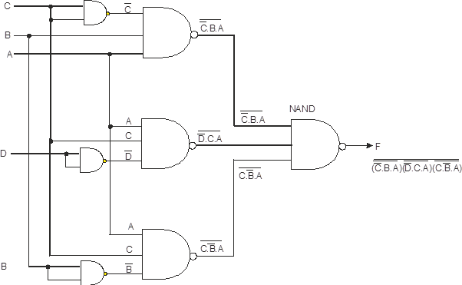  
**Figure-9: Implementing the simplified function with NAND gates only**

### Nor gate as Universal Gate

NOR gate is actually a combination of two logic gates: OR gate followed by NOT gate. So its output is complement of the output of an OR gate.This gate can have minimum two inputs, output is always one. By using only NOR gates, we can realize all logic functions: AND, OR, NOT, Ex-OR, Ex-NOR, NAND. So this gate is also called universal gate.

#### 2.1) NOR gates as OR gate

A NOR produces complement of OR gate. So, if the output of a NOR gate is inverted, overall output will be that of an OR gate.

**Y = ((A+B)’)’  
Y = (A+B)**

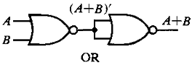  
**Figure-10: NOR gates as OR gate**

  
**Figure-11: Truth table of OR**

#### 2.2) NOR gates as AND gate

From DeMorgan’s theorems:  
(A+B)’ = A’B’  
(A’+B’)’ = A’’B’’ = AB  
So, give the inverted inputs to a NOR gate, obtain AND operation at output.

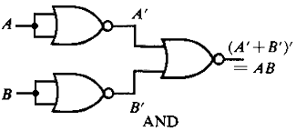  
**Figure-12:NOR gates as AND gate**

  
**Figure-13:Truth table of AND**

#### 2.4) NOR gates as Ex-OR gate

Ex-OR gate is actually Ex-NOR gate followed by NOT gate. So give the output of Ex-NOR gate to a NOT gate, overall output is that of an Ex-OR gate.  
Y = A’B+ AB’

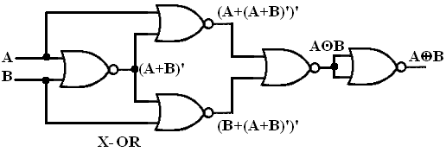  
**Figure-14: NOR gates as Ex-OR gate**

  
**Figure-15: Truth table of Ex-OR**

#### 2.3) NOR gates as Ex-NOR gate

The output of a two input Ex-NOR gate is shown by: Y = AB + A’B’. This can be achieved with the logic diagram shown in the left side.

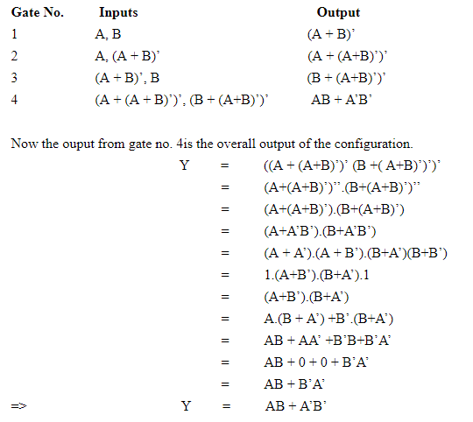

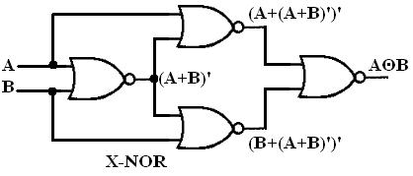  
**Figure-16: NOR gates as Ex-NOR gate**

  
**Figure-17: Truth table of Ex-NOR**

#### 2.5) Constructing a circuit with NOR gates only

Designing a circuit with NOR gates only uses the same basic techniques as designing a circuit with NAND gates; that is, the application of deMorgan’s theorem. The only difference between NOR gate design and NAND gate design is that the former must eliminate product terms and the later must eliminate sum terms.  
**F=(((C.B'.A)+(D.C'.A)+(C.B'.A))')'**

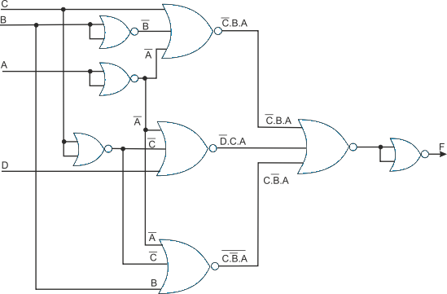  
**Figure-18: Implementing the simplified function with NOR gates only**

### PROCEDURE:

Step-1) Select and drag    ""  for generate wire of the circuit.  
Step-2) Join the wire to perform the require logic.

##### Note: Follow these steps for all experiments.

### [SIMULATION:](https://de-iitr.vlabs.ac.in/exp/truth-table-gates/simulation.html)

1. **NAND AS UNIVERSAL**
2. NAND as OR



1. NAND as AND



1. NAND as EX-OR



1. NAND as EX-NOR



1. Solving expression using NAND



1. **NOR AS UNIVERSAL**
2. NOR as OR



1. NOR as AND



1. NOR as EX-OR



1. NOR as EX-NOR



1. Solving expression using NOR



**EXPERIMENT-5**

**AIM:**

#### To verify the truth table and timing diagram of NOR gate latch using NOR gate IC and analyse the circuit of NOR gate latch with the help of LEDs display.

### THEORY:

Latches are basic storage elements that operate with signal levels (rather than signal transitions). Latches controlled by a clock transition are flip-flops. Latches are edge-sensitive devices. Latches are useful for the design of the asynchronous sequential circuit.

SR (Set-Reset) Latch – SR Latch is a circuit with:  
  
(i) 2 cross-coupled NOR gates or 2 cross-coupled NAND gates.  
(ii) 2 inputs S for SET and R for RESET.  
(iii) 2 outputs Q, Q.  
  
The SR Latch using NOR gate is shown below with its truth table:

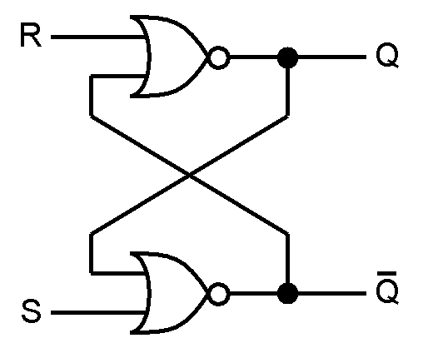  
**Figure-1:Logic Symbol of NOR gate latch**  
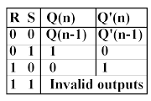  
**Figure-2:Truth Table of NOR gate latch**

While the R and S inputs are both low, feedback maintains the Q and Q outputs in a constant state, with Q the complement of Q. If S (Set) is pulsed high while R (Reset) is held low, then the Q output is forced high, and stays high when S returns to low; similarly, if R is pulsed high while S is held low, then the Q output is forced low, and stays low when R returns to low.The R = S = 1 combination is called a restricted combination or a forbidden state because, as both NOR gates then output zeros, it breaks the logical equation Q = Q. The combination is also inappropriate in circuits where both inputs may go low simultaneously (i.e. a transition from restricted to keep). The output would lock at either 1 or 0 depending on the propagation time relations between the gates (a race condition).

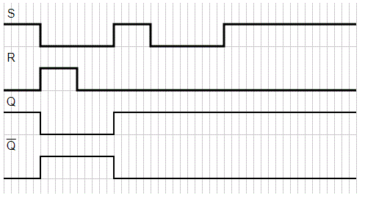

**Figure-3:Timing Diagram of NOR gate latch**

### PROCEDURE:

Step-1) Connect the supply(+5V)      to the circuit.  
Step-2) Press switch 1     for input R(Reset) and switch 2      for input S(Set).  
Step-3) Then press "ADD" button to add data in the given truth table and simultaneously generate the timing diagram.  
Step-4) Repeat step 2 and step 3 for another set of data.  
Step-5) Press the "Print" button after completing your simulation to get your results.

### [SIMULATION:](https://de-iitr.vlabs.ac.in/exp/truth-table-gates/simulation.html)



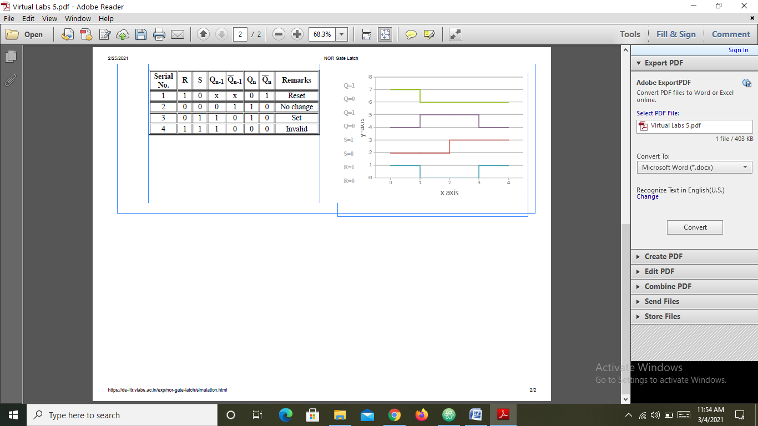

**EXPERIMENT-6**

**AIM:**

#### To verify the truth table and timing diagram of RS, JK, T and D flip-flops by using NAND & NOR gates ICs and analyse the circuit of RS, JK, T and D flip-flops with the help of LEDs display.

### THEORY:

A flip flop is an electronic circuit with two stable states that can be used to store binary data. The stored data can be changed by applying varying inputs. Flip-flops and latches are fundamental building blocks of digital electronics systems used in computers, communications, and many other types of systems.

1) R-S flip flop  
2) D flip flop  
3) J-K flip flop  
4) T flip flop  
The basic NAND gate RS flip flop circuit is used to store the data and thus provides feedback from both of its outputs again back to its inputs. The RS flip flop actually has three inputs, SET, RESET and its current output Q relating to its current state as shown in figure below.

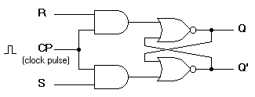  
**Figure-1:R-S flip flop circuit diagram**  
  
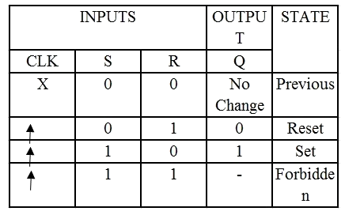  
**Figure-2:Characteristics table of R-S flip flop**

### 2) D flip flop

A D flip flop has a single data input. This type of flip flop is obtained from the SR flip flop by connecting the R input through an inverter, and the S input is connected directly to data input. The modified clocked SR flip-flop is known as D-flip-flop and is shown below. From the truth table of SR flip-flop we see that the output of the SR flip-flop is in unpredictable state when the inputs are same and high. In many practical applications, these input conditions are not required. These input conditions can be avoided by making them complement of each other.

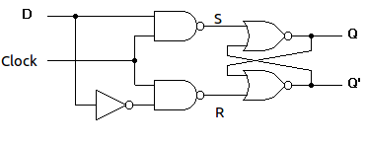  
**Figure-3:Circuit diagram of D flip flop**

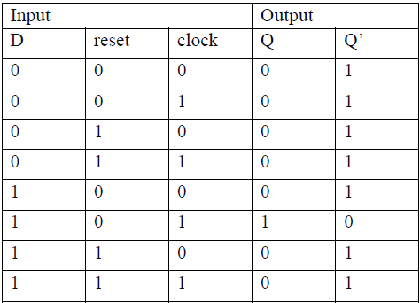  
**Figure-4:Characteristics table of D flip flop**

### 3) J-K flip flop

In a RS flip-flop the input R=S=1 leads to an indeterminate output. The RS flip-flop circuit may be re-joined if both inputs are 1 than also the outputs are complement of each other as shown in characteristics table below.

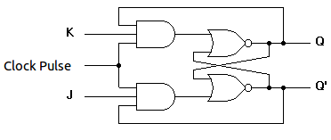  
**Figure-5:Circuit diagram of J-K flip flop**

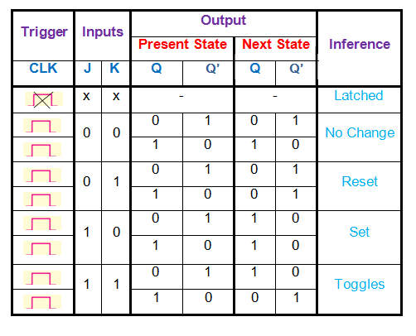  
**Figure-6:Characteristics table of J-K flip flop**

### 4) T flip flop

T flip-flop is known as toggle flip-flop. The T flip-flop is modification of the J-K flip-flop. Both the JK inputs of the JK flip – flop are held at logic 1 and the clock signal continuous to change as shown in table below.

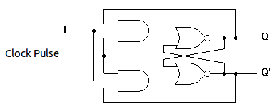  
**Figure-7:Circuit diagram of T flip flop**  
  
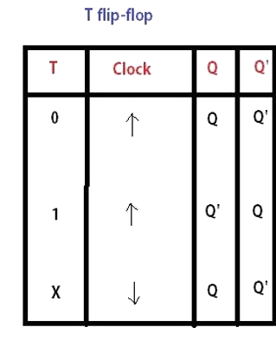  
**Figure-8:Characteristics table of T flip flop**

### PROCEDURE:

### 1) SR flip flop

Step-1) Connect the supply(+5V)       to the circuit.  
Step-2) First press "ADD" button to add basic state of your output in the given table.  
Step-3) Press the switches to select the required inputs "S" and "R" and apply the clock pulse.  
Step-4) Press "ADD" button to add your inputs and outputs in the given table and their corresponding graph.  
Step-5) Repeat steps 3&4 for next state of inputs and their corresponding outputs.  
Step-6) Press the "Print" button after completing your simulation to get your results.

### [SIMULATION:](https://de-iitr.vlabs.ac.in/exp/truth-table-gates/simulation.html)



### 2) D flip flop

Step-1) Connect the supply(+5V)       to the circuit.  
Step-2) First press "ADD" button to add basic state of your output in the given table.  
Step-3) Press the switches to select the required inputs "D" and "Clock" .  
Step-4) Press "ADD" button to add your inputs and outputs in the given table and their corresponding graph.  
Step-5) Repeat step 3 & step 4 for next state of inputs and their corresponding outputs.  
Step-6) Press the "Print" button after completing your simulation to get your results.

### [SIMULATION:](https://de-iitr.vlabs.ac.in/exp/truth-table-gates/simulation.html)



### 3) J-K flip flop

Step-1) Connect the supply(+5V)       to the circuit.  
Step-2) First press "ADD" button to add basic state of your output in the given table.  
Step-3) Press the switches to select the required inputs "S" and "R" and apply the clock pulse.  
Step-4) Press "ADD" button to add your inputs and outputs in the given table and their corresponding graph.  
Step-5) Repeat step 3 & step 4 for next state of inputs and their corresponding outputs.  
Step-6) Press the "Print" button after completing your simulation to get your results.

### [SIMULATION:](https://de-iitr.vlabs.ac.in/exp/truth-table-gates/simulation.html)



### 4) T flip flop

Step-1) Connect the supply(+5V)       to the circuit.  
Step-2) First press "ADD" button to add basic state of your output in the given table.  
Step-3) Press the switches to select the required inputs "T" and apply the clock pulse.  
Step-4) Press "ADD" button to add your inputs and outputs in the given table and their corresponding graph.  
Step-6) Press the "Print" button after completing your simulation to get your results.

### [SIMULATION:](https://de-iitr.vlabs.ac.in/exp/truth-table-gates/simulation.html)

